Exp No : 10
PIR SENSOR IN PROTEUS USING ARDUINO
AIM :
To write an embedded C Program for interfacing PIR Sensor using Arduino and Proteus
SOFTWARE REQUIRED :
- Proteus 8 software
- Arduino IDE software
PROGRAM :
int Status = 13; // Digital pin D6
int sensor = 12; // Digital pin D7

void setup() {
Serial.begin(9600);

pinMode(sensor, INPUT); // declare sensor as input
pinMode(Status, OUTPUT); // declare LED as output
}

void loop() {
long state = digitalRead(sensor);

Serial.println(state);

if (state == HIGH) {
digitalWrite(Status, HIGH);
Serial.println("Motion detected!");
delay(1000);
}
else {
digitalWrite(Status, LOW);
Serial.println("Motion absent!");
delay(1000);
}
}

OUTPUT :
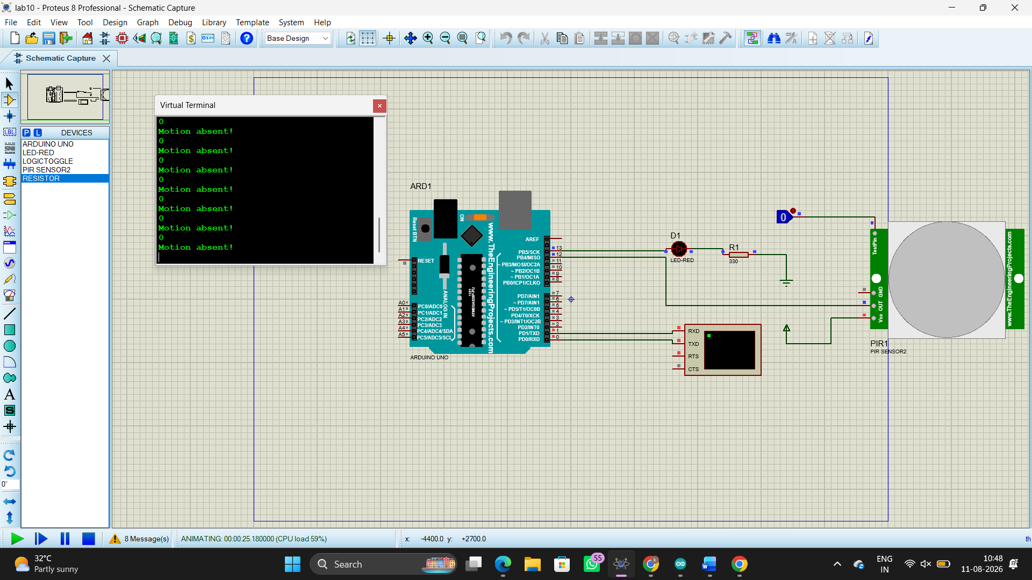
RESULT :
Thus the program has been successfully verified and executed.

